Document Identifier | Number: | 193-A02.01-0018 |  | Rev: | 0
Title: | DID E096-1 – Final Certified Weight |  |  | Ship applicability: | All
Document Owner: | B. White, Jr. Naval Architect | Document Approver: | L. Aguiar, Manager Naval Architecture
Master Template Ref: | DID Template |  |  | Project: | All
Type | Organisation | Area | Supplier | VSY Supplier Code | SWBS
DID | Supply Chain | Subcontracts / SCM | NA | NA | NA
Data Item Description
Final Certified Weight
DID E096-1

Prepared by: Vancouver Shipyards Co. Ltd.
50 Pemberton Ave.
North Vancouver, BC, Canada, V7P 2R2
Tel: (604) 988-3111
Fax: (604) 984-1636
© Vancouver Shipyards Co. Ltd. 2016
.

Purpose
Supplier weight control is required in order for the Supplier to be to be conscious of the mass properties of the Equipment throughout the design and manufacture and its impact on the Ship on which it will be installed. Weight and moment control is critical to the Purchaser meeting its naval architectural contractual requirements for list, trim, service life allowance, and performance. Therefore, it is imperative that the Supplier submit accurate weight data for the purchased item.

References
This DID must be read in conjunction with Part 3 (Engineering) of Schedule D1 (SOW).

Preparation Instructions
The supplier shall provide a DID Compliance Matrix indicating which submission files contain the items listed in this DID.
For written style documents (eg. manuals, performance specification documents, etc) larger than 10 pages the document shall include a Table of Contents that contains links to the various section headers within the document.

Content and structure
CONTENT
The Supplier shall report weight and centre of gravity information to the purchaser as follows:
- Final Certified Weight - Prior to crating of the Equipment for shipment, the Supplier shall weigh the Equipment. The following information shall be forwarded to the Purchaser:
- Scale weight of the Equipment (with clear indication of dry or wet weight);
- List of accessories and other parts of the Equipment which have not been included in the above weight;
- Brief description of the weighing device:
- Type and make of scale;
- Accuracy;
- Maximum rated capacity;
- Sensitivity; and
- Scale calibration data.

- Location of Centre of Gravity - The supplier shall provide a location of the centre of gravity of the Equipment in an operating condition.

Structure
- Attachment A: Equipment Centre of Gravity Specifications Sketch
- Attachment B: Supplier Equipment Weight Reporting Form

Special Instructions
Notes for completing Attachment A - Equipment Centre of Gravity Specifications Sketch
Provide an estimated location of the Center of Gravity of the Equipment in an operating condition by a sketch as per the sample format provided. If already provided on a drawing supplied by the Supplier, just submit the drawing; a sketch would not be required.

Notes for completing Attachment B - Supplier Equipment Weight Reporting Form
Each individual or separate Equipment Item supplied should be reflected on this form. Additional sheets may be added as necessary to provide the information requested.
A. Supplier Information:
- Enter name of your company for Supplier Name.
- Provide the name of the original manufacturer, if you are acting as an agent for a product produced by another firm. If you are both the supplier and the manufacturer, this box may be left blank.
- Provide the model number of the supplied item(s) if applicable.
- Provide the Purchase Order No. and Item No. under which you are providing this Equipment.
- Provide a brief description of the Item(s) being supplied.
- Provide the VSY Part Number of the item(s), if known. Otherwise, leave blank.
- Provide the Supplier Drawing Number, which describes the item(s) supplied.
- Enter VSY Hull Number if known, otherwise, leave blank.
- Enter VSY Drawing Number if known, otherwise, leave blank.

B. Weighed Weight and CG Information:
- Enter name of Weighed Item of Equipment.
- Provide the unit weighed weight of each Item of Equipment.

This weight should not include any packaging, dunnage, or temporary additions. The weight reported should be the weight of the Item of Equipment, as it will be installed on the Ship. Use appropriate unit of measure, for example:
A. For pipe and cable, weight should be reported as kg per linear meter.
B. For tile, weight should be reported as kg, per cubic meter or kg per square meter.

C. List of Item(s) Not Included in Weighed Weight:
- Enter the estimated/calculated weight of any missing operating fluids or additional accessories not included in the weighed weight that are required for a normal operating ship condition.

D. Weighing Equipment Information:
- Provide the information on the weighing equipment used to measure weight.

E. Approval Signature:
- Provide signature/name signifying that the data provided for use in weight estimating accurately and completely describes the item furnished to the best of your capability.

F. Proof of Calibration
- Provide attachment with evidence of calibration of weighing equipment used at time of weighing (i.e. Calibration Certificate)

Attachment A – Sample Centre of Gravity Sketch

Sketch Indicating the Centre of Gravity and Reference Points:

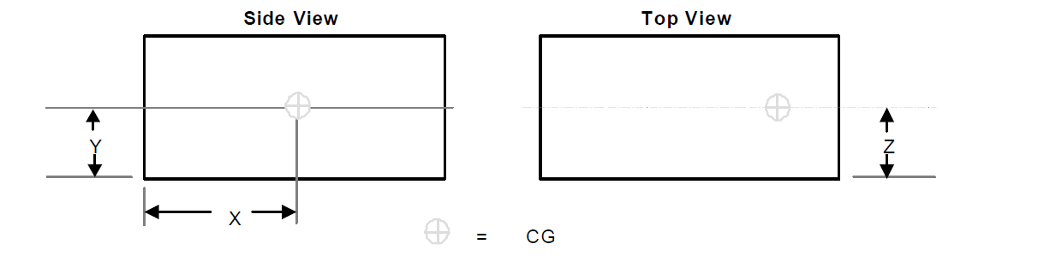

Attachment B - Supplier Weight Reporting Form
- Supplier Information:
Supplier Information
Supplier Name:
Manufacturer (If Different than Supplier):
Model Number (If Applicable):
Purchase Order Number:
VSY Part Number:
Hull Number:
Supplier Drawing Number(s):
VSY Drawing Number(s):

- Weight Information of Weighed Equipment(s):
Final Recorded Weight(s)
Weighed Item of Equipment | Recorded Weight (kg) | Notes

- List of Item(s) Not Included in Weighed Weight (i.e. Operating Fluids etc.):
Additional Items Not Weighed, Required for Normal Ship Operation
Item of Equipment | Weight (kg) | Notes

- Weighing Equipment Information:
Weighing Equipment
Make:
Type:
Range:
Accuracy:
Calibration Date:
Date Weighed:

- Approval Signature
The Technical Information on This Form Accurately and Completely Describe the Item(s) Furnished
Printed Name:
Signature:
Date:
- Proof of Calibration

Attach evidence of calibration of weighing equipment at time of weighing (i.e. Calibration Certificate)

